Climate Summary Access Guide

- Once the server starts user can access the application http://localhost:8080/climate
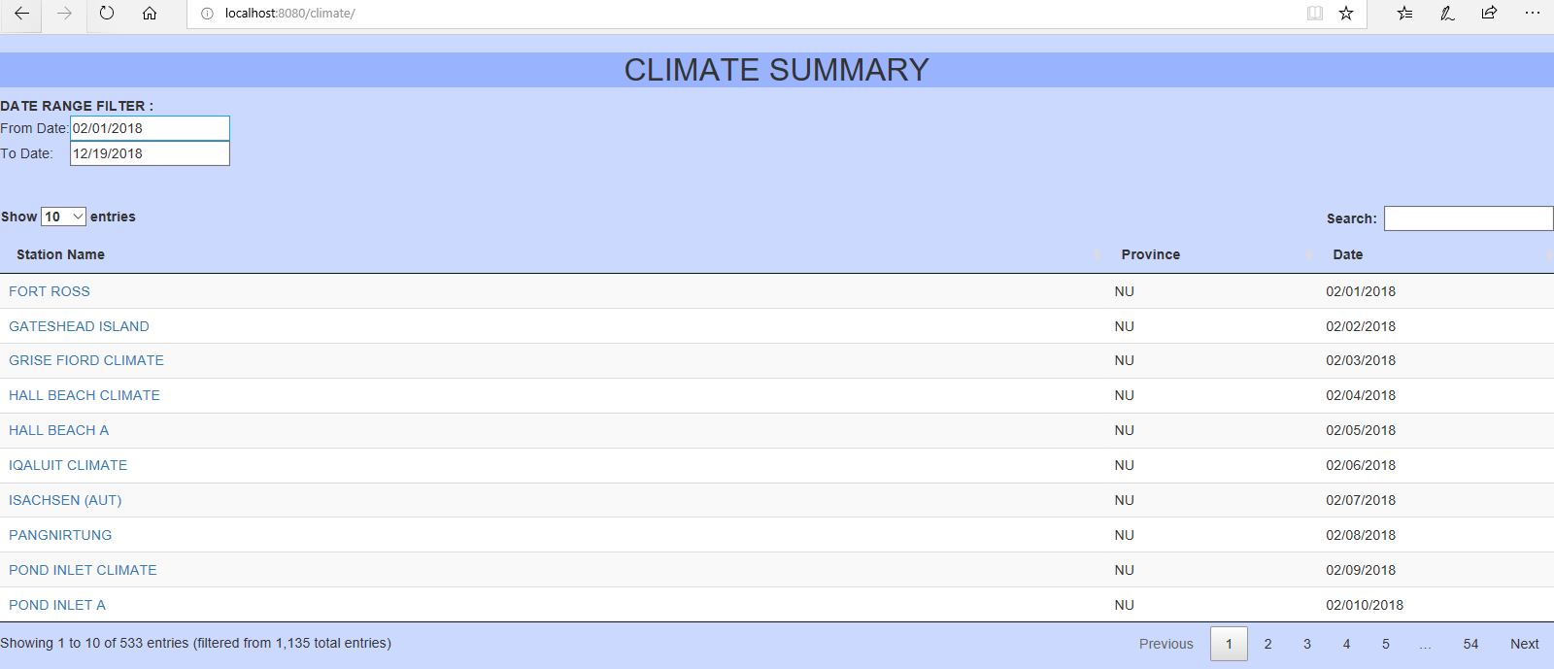

2. Once the climate summary loaded, the user can have the following options
a) The user can control how many records to display in the screen
b) The user can filter the records
c) The user can browse next, previous, first and last pages
d) The user is allowed to view details view by hitting hyperlink in the station name
f) User allowed filtering the data based on date range
g) The user can sort the data by columns
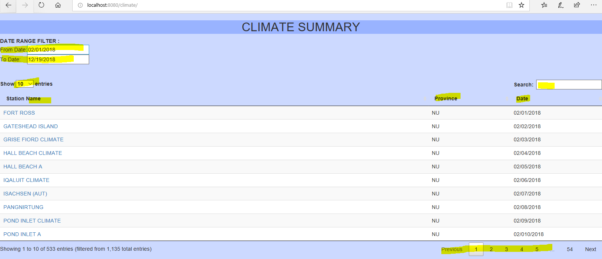

3.Climate details page. From this user allowed to access the previous screen by clicking the “Go Back” button.
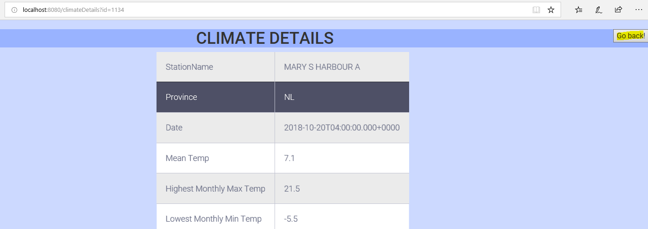
- If the user enters the wrong URL
